Problem Statement: Stepwise Execution Analysis of a Dynamic Programming Algorithms
Longest Common Subsequence (LCS)

Theory:
- Initialize lengths.
  - Compute m as the number of characters in s1.
  - Compute n as the number of characters in s2.
- Create DP table.
  - Make a 2D table dp with (m + 1) rows and (n + 1) columns.
  - Set every cell dp[i][j] to 0 initially.
  - Interpretation: dp[i][j] will store the length of the LCS between the first i characters of s1 and the first j characters of s2.
- Fill DP table (bottom-up dynamic programming).
  - For every i from 1 to m:
    - For every j from 1 to n:
      - Compare the characters s1[i-1] and s2[j-1].
      - If they are equal:
        - Set dp[i][j] = dp[i-1][j-1] + 1.
        - (Meaning: extend the LCS found for the prefixes by this matching character.)
      - Otherwise:
        - Set dp[i][j] = max(dp[i-1][j], dp[i][j-1]).
        - (Meaning: the best LCS so far is either skipping the current char of s1 or skipping the current char of s2.)
- Prepare to reconstruct the LCS string.
  - Create an empty string lcs for building the result.
  - Set indices i = m and j = n to start from the bottom-right cell of the DP table.
- Backtrack to build the LCS (from dp[m][n] back to dp[0][0]).
  - While both i > 0 and j > 0:
    - If s1[i-1] equals s2[j-1]:
      - Append that character to the end of lcs (use push_back).
      - Move diagonally: decrement both i and j by 1.
      - (This character is part of the LCS.)
    - Else:
      - Compare dp[i-1][j] and dp[i][j-1]:
        - If dp[i-1][j] > dp[i][j-1], decrement i (move up).
        - Otherwise, decrement j (move left).
- Fix the order of the LCS.
  - The backtracking appended characters in reverse order (from end to start).
  - Reverse the string lcs to get the correct left-to-right LCS.
- Output results.
  - Print lcs as the LCS sequence.
  - Print dp[m][n] as the LCS length (the value at the bottom-right of the DP table).
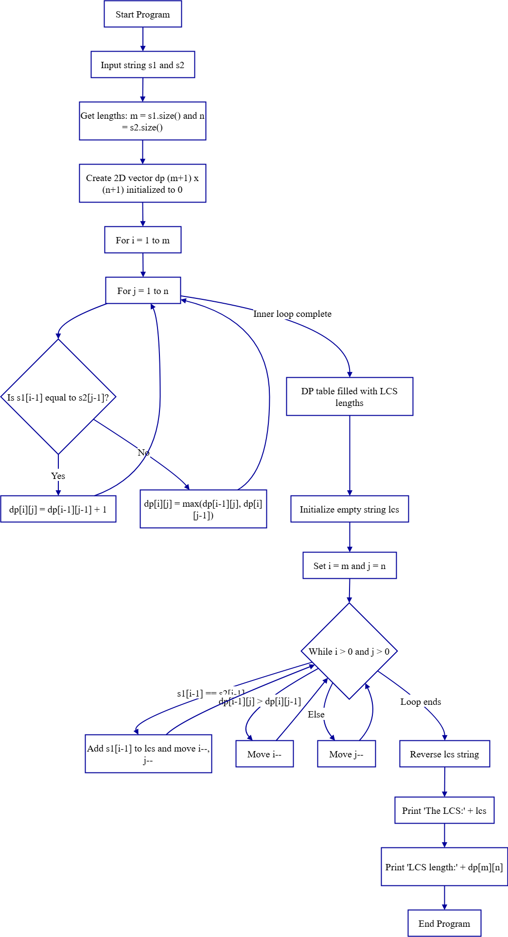
Flow Chart:
Code:

- #include <bits/stdc++.h>
- using namespace std;

- void lcsAlgo(const string &s1, const string &s2) {
- int m = s1.size(), n = s2.size();
- vector<vector<int>> dp(m + 1, vector<int>(n + 1, 0));

- for (int i = 1; i <= m; ++i) {
- for (int j = 1; j <= n; ++j) {
- if (s1[i - 1] == s2[j - 1])
- dp[i][j] = dp[i - 1][j - 1] + 1;
- else
- dp[i][j] = max(dp[i - 1][j], dp[i][j - 1]);
- }
- }

- string lcs;
- int i = m, j = n;
- while (i > 0 && j > 0) {
- if (s1[i - 1] == s2[j - 1]) {
- // lcs.insert(lcs.begin(), s1[i - 1]);
- lcs.push_back(s1[i - 1]);
- i--; j--;
- }
- else if (dp[i - 1][j] > dp[i][j - 1])
- i--;
- else
- j--;
- }

- reverse(lcs.begin(), lcs.end());

- cout << "The LCS: " << lcs << endl;
- cout << "LCS length: " << dp[m][n] << endl;
- }

- int main() {
- string s1, s2;
- cout << "The first sequence: ";
- cin >> s1;
- cout << "The second sequence: ";
- cin >> s2;

- lcsAlgo(s1, s2);
- }
Screenshots:
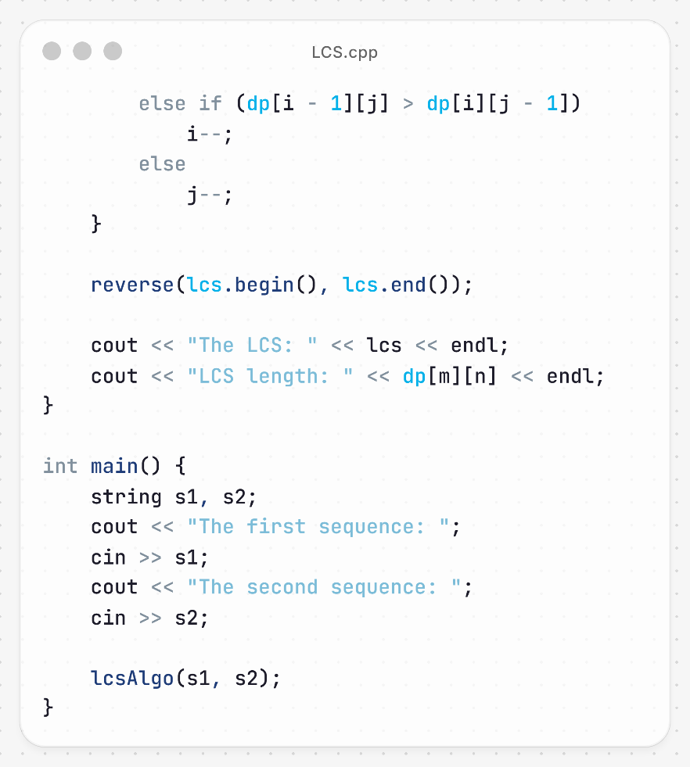
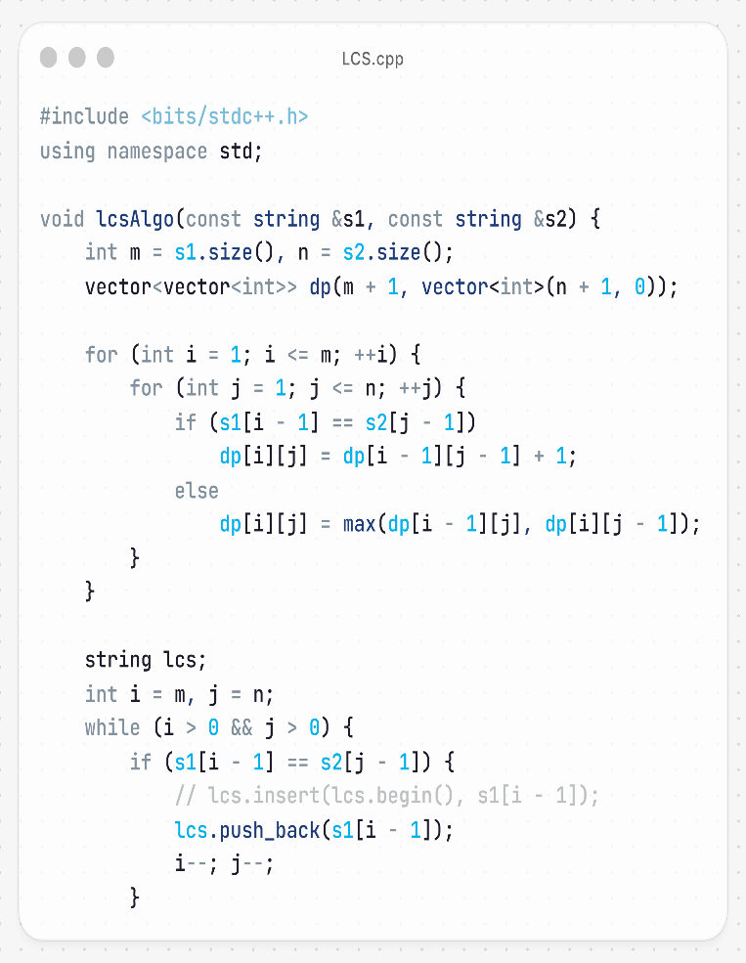

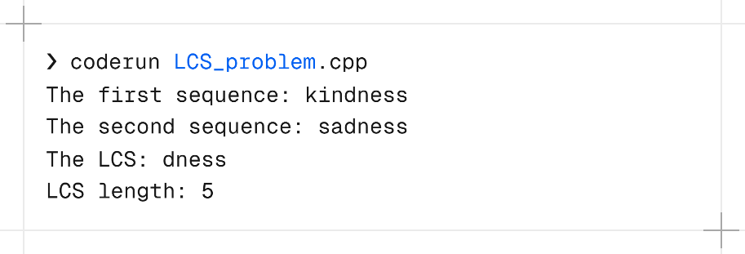

Analysis:
Input:
s1 = “kindness”
s2 = “sadness”

Step 1:
 | k | i | n | d | n | e | s | s
s | 0 | 0 | 0 | 0 | 0 | 0 | 0 | 0
a | 0 | 0 | 0 | 0 | 0 | 0 | 0 | 0
d | 0 | 0 | 0 | 1 | 1 | 1 | 1 | 1
n | 0 | 0 | 0 | 1 | 2 | 2 | 2 | 2
e | 0 | 0 | 0 | 1 | 2 | 3 | 3 | 3
s | 0 | 0 | 0 | 1 | 2 | 2 | 4 | 4
s | 0 | 0 | 0 | 1 | 2 | 2 | 3 | 5

Step 2: Backtracking to find LCS
- Start from the bottom-right of the table.
- Compare characters in reverse order:
- Last character s1[7]='s' matches s2[6]='s' → include 's'.
- Move diagonally to previous matching 's' in both strings → include 's'.
- 'e' in s1 matches 'n' in s2 → include 'e'.
- 'n' in s1 matches 'e' in s2 → include 'n'.
- 'd' in s1 matches 'e' in s2 → include 'd'.

Step 3: LCS length
- The LCS "dness" has length 5.

Step 4: Observations
- Both strings share the suffix "dness" → that’s the longest common sequence.
- The LCS does not include the initial letters 'k' or 'i' from "kindness" or 's', 'a' from "sadness" because they don’t appear in the same order in both strings.

Final Output:
Length of LCS = 5
LCS = “dness”

Complexity Analysis:
- Time Complexity: Filling the DP table takes O(m × n) time, where m and n are the lengths of the two strings. Each cell computation is constant, and backtracking to construct the LCS takes O(m + n), which is negligible compared to table filling.
- Space Complexity: The DP table requires O(m × n) space. If only the LCS length is needed, memory can be optimized to O(min(m, n)), but storing the actual sequence requires the full table for backtracking.

Conclusion:
The dynamic programming approach for LCS is a systematic and reliable method to find the longest common subsequence between two sequences. It ensures an exact solution by building a table of optimal subproblem solutions and then reconstructing the sequence through backtracking. This method works efficiently for moderately sized strings, is versatile across different types of sequences, and is widely used in applications like text comparison, bioinformatics, and version control. Its combination of accuracy, predictability, and reasonable efficiency makes it a standard and practical approach in computer science.

